Tony Sulfaro

CSE 335.730

Professor Liu

Homework 02 – Hiding

1. Show for public inheritance, for the public data and functions in the base class, they can be accessed by the derived class, and they also can be accessed like public data and functions of the derived class by both the clients of the derived class and further derived classes.
   1. No accessor errors for this one. Clients and derived classes have access to public attributes. It will throw an error if you make it const and try to modify it though (const string publicThing) for example. 
   2. publicString in the Person class can be accessed through client in main through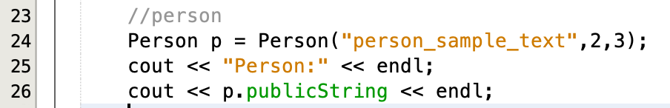
   3. can also initialize an instance of a derived class and publicString is still available from the client as it inherits it in the student class publicly.
2. Show for public inheritance, for protected data and functions in the base class, they can be accessed by the derived class, and they can also be accessed like protected data and functions of the derived class by further derived classes.
   1. Note how the Student class has access to the protected data in the Person class. This is because inherited classes have access to protected data/methods in the parent class.
   2. 
   3. The derived class derivedStudnet still has access to public and protected attributes while private ones are sill inacessable.
   4. 
3. Show for public inheritance, for private data and functions in the base class, they cannot be accessed by the derived class.
   1. If you instantiate a Student class that inherits from the Person class it does not have access to the private int socialSecurityNumber. 
4. Show for protected inheritance, for public and protected data and functions in the base class, they can be accessed by the derived class, and also, they can be accessed like protected data and functions of the derived class by further derived classes.
   1. Public data publicString can be accessed by any number of inherited classes even if the inherited class inherits from another inherited class. CSE335student that inherits from ProtectedStudent has access to publicThing just like the Student class does and even has access to the protected data in the Person class as well.
   2. 
5. Show for protected inheritance, for private data and functions in the base class, they cannot be accessed by the derived class.
   1. The ProtectedStudent class does not have access to the private social security in the person class. When trying to access it it throws an error
   2. 
6. Show for private inheritance, for public and protected data and functions in the base class, they can be accessed by the derived class, but they cannot be accessed by the clients of the derived class and they cannot be accessed by any further derived classes.
   1. Trying to access public, protected, or private attributes from the Person class are not possible directly from the client but accessing public and protected data is possible from within the class itself (PrivateStudent).
   2. 
   3. PrivateStudent has access to public and protected attributes from the Person class only
   4. 
   5. PrivateCSE335stuent does not have access to any attributes from the PrivateStudent class as PrivateStudent inherited attributes from the Person class privately.
   6. 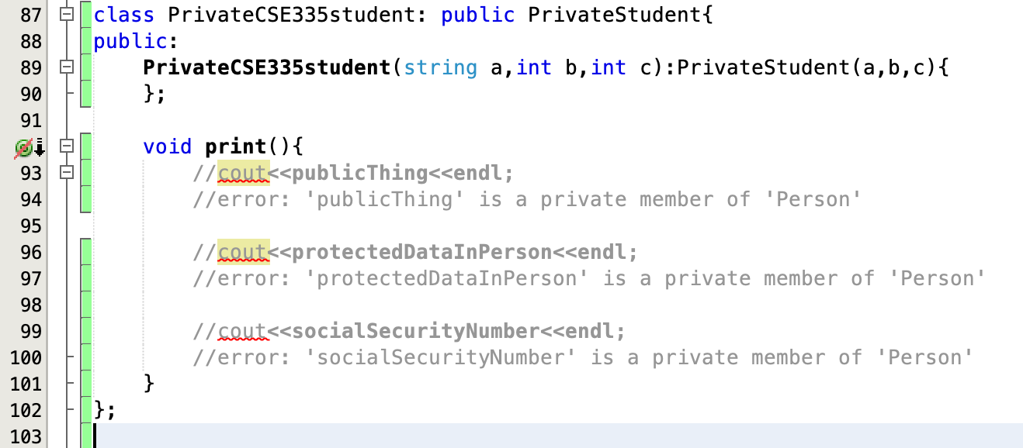
7. Show for private inheritance, for private data and functions in the base class, they cannot be accessed by the derived class.
   1. Class PrivateStudent privately inherits from the Person class. As a result private attribute socialSecurityNumber is not accessible from the derived class PrivateStudent.
   2. 